
INTELLIGENT MULTI-CLOUD SECURITY
POSTURE MANAGEMENT SYSTEM
CAPSTONE PROJECT REPORT
Course: ITA1406 – Ethical Hacking
Guided By: Dr A Ezhil Grace

Presented By
Atchaya Chandran R 192521394
Hariharan B 192511394
Mukesh V 192524359

SIMATS ENGINEERING
Saveetha Institute of Medical and Technical Sciences
Chennai – 602105
SEPTEMBER 2026

BONAFIDE CERTIFICATE
This is to certify that the Capstone Project entitled “INTELLIGENT MULTI-CLOUD SECURITY POSTURE MANAGEMENT SYSTEM has been carried out by Atchaya Chandran R (192521394) under the supervision of Dr A Ezhil Grace and is submitted in partial fulfilment of the requirements for the course ITA1406 – Ethical Hacking at SIMATS Engineering, Saveetha Institute of Medical and Technical Sciences, Chennai.

Program Director | Guide
Dr. Parthiban (course coordinator) | Dr A Ezhil Grace
Professor | Assistant Professor (SG)
Department of Computer Science | Department of VLSI Microelectronics
Saveetha School of Engg. | Saveetha School of Engg.

DECLARATION
I Atchaya Chandan R (192521394) hereby declare that the capstone project entitled “Intelligent Multi-Cloud Security Posture Management System” has been prepared as an academic project for ITA1406 – Ethical Hacking. The work presented in this report is intended to demonstrate the application of ethical-hacking and cybersecurity engineering principles to the security management of multi-cloud environments.
The system concept is based on the project presentation supplied for this course. The presentation identifies centralized visibility, security misconfigurations, compliance challenges, delayed threat detection and manual security management as the principal problems addressed by the project.
We further declare that cybersecurity testing, cloud assessment and any security-related experimentation must be performed only on systems for which appropriate authorization has been obtained. No unauthorized access, scanning or exploitation is intended.
Where the supplied project material does not provide an exact implementation detail, this report identifies the material as a design explanation, evaluation recommendation or future improvement rather than presenting unsupported implementation claims.
Place: Chennai
Date: 08/09/2026
Student Signatures
Atchaya Chandran R-192521394

INDIVIDUAL CONTRIBUTION STATEMENT
The project is organized into three principal technical modules. The contribution distribution below is a report-ready allocation based on those modules and should be edited if the team's actual records differ.
Member | Major Responsibility | Detailed Work | Contribution
Mukesh | Architecture + Module 1 | System architecture, multi-cloud integration, asset discovery, configuration/security assessment, dashboard coordination and documentation. | 25%
Hariharan B | Module 2 | AI-based threat detection, anomaly detection, threat classification, risk analysis and threat-intelligence correlation. | 25%
Atchaya Chandran R | Module 3 | Automated security response, remediation, compliance monitoring, security policy enforcement and reporting. | 50%
TOTAL |  |  | 100%

Contribution to Engineering Outcome
Atchaya Chandran R's architecture role connects the three modules and establishes the overall system flow. Hariharan's analytical role focuses on converting cloud activity into security findings and risk information. Mukesh's role closes the loop by connecting findings to response, remediation and compliance verification.
The team contribution should be supported in the final submission using screenshots, meeting records, module outputs, test evidence and presentation responsibilities where required by the faculty.

ABSTRACT
Cloud computing has become an important foundation for modern applications and services. Organizations may use multiple cloud platforms simultaneously to obtain flexibility, resilience and access to specialized services. However, multi-cloud adoption creates a complex security-management environment because resources, configurations, identities, logs and policies are distributed across heterogeneous platforms.
The Intelligent Multi-Cloud Security Posture Management System (MCSPM) is designed as a centralized security-management solution that monitors and manages multiple cloud platforms through a unified dashboard. The project presentation states that the system uses Artificial Intelligence to detect security risks, misconfigurations and compliance issues in real time and provides centralized visibility, automated alerts and quick remediation.
The system consists of three principal modules. Module 1 performs multi-cloud asset discovery and security assessment across AWS, Azure and Google Cloud. Module 2 performs intelligent threat detection and risk analysis through AI-based detection, anomaly detection, risk assessment, threat-intelligence analysis and real-time alerts. Module 3 provides automated security response, compliance monitoring, policy enforcement, remediation and reporting.
The reported outcomes include a 94.7% security posture score, 2,962 discovered and monitored cloud assets, 18 active threats, 4 critical risks and 97.4% AI confidence in threat detection. Continuous compliance monitoring and automated reporting are also reported.
The project demonstrates an integrated workflow in which cloud assets are discovered, assessed, monitored, prioritized and acted upon. It therefore combines cloud-security posture management with intelligent analytics and security automation.
Keywords: Multi-Cloud Security, CSPM, Ethical Hacking, Artificial Intelligence, Machine Learning, Threat Detection, Risk Analysis, Automated Remediation, Compliance Monitoring.

TABLE OF CONTENTS
- Certificate
- Declaration
- Individual Contribution Statement
- Abstract
- Chapter 1 – Introduction and Engineering Problem
- Chapter 2 – Literature Review and Existing Solutions
- Chapter 3 – Engineering Design and Security Analysis
- Chapter 4 – Implementation, Testing and Results
- Chapter 5 – Conclusion, Future Scope and Reflection
- References
- Appendices

LIST OF FIGURES
No. | Figure
1 | Multi-cloud security problem context
2 | Overall MCSPM architecture
3 | Module 1 asset-discovery workflow
4 | Configuration assessment workflow
5 | Module 2 threat-detection workflow
6 | Anomaly detection concept
7 | Risk prioritization workflow
8 | Module 3 automated response workflow
9 | Compliance monitoring workflow
10 | User interface/dashboard
11 | Security posture results
12 | Risk matrix
13 | Requirements traceability
14 | Project Gantt chart

LIST OF TABLES
No. | Table
1 | Stakeholder requirements
2 | Functional requirements
3 | Non-functional requirements
4 | Cloud-security challenges
5 | Existing-solution comparison
6 | Architecture components
7 | Design trade-offs
8 | Threat model
9 | Risk register
10 | Standards alignment
11 | Implementation components
12 | Test plan
13 | Reported results
14 | Objective achievement
15 | Team responsibilities

LIST OF ABBREVIATIONS AND SYMBOLS
Abbreviation | Meaning
MCSPM | Multi-Cloud Security Posture Management
CSPM | Cloud Security Posture Management
AI | Artificial Intelligence
ML | Machine Learning
AWS | Amazon Web Services
IAM | Identity and Access Management
API | Application Programming Interface
SIEM | Security Information and Event Management
SOC | Security Operations Center
CVE | Common Vulnerabilities and Exposures
CVSS | Common Vulnerability Scoring System
NIST | National Institute of Standards and Technology
CSF | Cybersecurity Framework
CSA | Cloud Security Alliance
ISO | International Organization for Standardization
CSP | Cloud Service Provider
TTP | Tactics, Techniques and Procedures
UI | User Interface
RBAC | Role-Based Access Control

Project At a Glance
Item | Project Detail
Project | Intelligent Multi-Cloud Security Posture Management System
Course | ITA1406 – Ethical Hacking
Clouds identified | AWS, Microsoft Azure, Google Cloud
Core modules | Asset Discovery; Intelligent Threat Detection; Automated Response & Compliance
Reported posture | 94.7%
Assets | 2,962
Active threats | 18
Critical risks | 4
AI confidence | 97.4%

The project presentation explicitly identifies AWS, Azure and Google Cloud as the supported cloud environments for asset discovery and security assessment, and identifies the three major functional modules. fileciteturn2file0L87-L122

CHAPTER 1 – INTRODUCTION AND ENGINEERING PROBLEM

1.1 Introduction
The growth of cloud computing has changed how organizations build and operate information systems. Instead of maintaining every component inside a single physical data centre, organizations can use cloud services to deploy resources dynamically. This flexibility improves scalability, but it also creates new security-management requirements.
A multi-cloud environment is more difficult to secure than an isolated environment because security teams must understand several provider-specific interfaces, configurations and policies. The project therefore approaches the problem from a centralized security-posture perspective.

1.2 Project Context
The supplied presentation describes MCSPM as a system that monitors and manages security across multiple cloud platforms from a single dashboard. It uses AI to detect risks, misconfigurations and compliance issues in real time and provides automated alerts and quick remediation. fileciteturn2file0L46-L55

1.3 Why Multi-Cloud Creates Complexity
- Different providers expose different management interfaces and configuration structures.
- Security policies may need to be translated into provider-specific controls.
- Asset inventories can become fragmented when each cloud is monitored independently.
- Security events can occur at different times and with different levels of detail.
- Risk prioritization requires organizational context, not merely technical findings.
- Manual remediation becomes difficult as the number of assets grows.

1.4 Engineering Perspective
From an engineering perspective, the challenge is to transform heterogeneous cloud information into a common security-management workflow. The platform must collect information, normalize it, assess security posture, identify threats, calculate risk and support corrective action.

1.5 Problem Statement
The project presentation identifies five principal problems: lack of centralized visibility, security misconfigurations, compliance challenges, delayed threat detection and manual security management. fileciteturn2file0L59-L68

1.5.1 Lack of Centralized Visibility
Security teams may need to move between several provider environments to understand the overall state of cloud resources. This makes organizational-level monitoring difficult. A centralized inventory provides a common view and supports consistent prioritization.

1.5.2 Security Misconfigurations
Cloud resources can become insecure because of incorrect configuration. A security posture platform must continuously identify configuration deviations and provide a mechanism for correction.

1.5.3 Compliance Challenges
Compliance requires evidence that required security controls are consistently applied. In a multi-cloud environment, control implementation can vary between providers, increasing the complexity of monitoring.

1.5.4 Delayed Threat Detection
Large quantities of cloud activity make manual detection difficult. Intelligent analytics can help identify unusual activity and prioritize events for investigation.

1.5.5 Manual Security Management
Manual security operations consume time and can introduce inconsistent responses. Automation can reduce repetitive work, provided that automated actions are properly controlled.

1.6 Objectives
- Discover and maintain an inventory of cloud assets across multiple cloud platforms.
- Identify security vulnerabilities and misconfigurations and assess the overall security posture.
- Detect cyber threats using intelligent analytics and AI-based techniques.
- Analyze, prioritize and evaluate risks based on severity, likelihood and potential business impact.
- Automate security incident response and remediation.

1.7 Scope
The scope covers the capabilities explicitly represented in the project presentation: AWS, Azure and Google Cloud discovery; configuration assessment; vulnerability identification; posture evaluation; AI threat detection; anomaly detection; risk assessment; threat intelligence; real-time alerts; automated response; compliance monitoring; policy enforcement; remediation; and reporting.

1.8 Stakeholder Requirements
Stakeholder | Need | Expected Benefit
Security Administrator | Unified security view | Faster security oversight
SOC Analyst | Threat and risk alerts | Faster investigation
Cloud Administrator | Asset/configuration visibility | Reduced unmanaged resources
Compliance Team | Continuous compliance status | Better audit readiness
Management | Security posture summary | Improved decision-making
Operations | Safe remediation | Reduced exposure time
End User | Secure services | Improved reliability

1.9 Functional Requirements
ID | Requirement
FR01 | Discover resources across supported cloud platforms.
FR02 | Maintain centralized asset inventory.
FR03 | Assess security-relevant configurations.
FR04 | Identify vulnerabilities and weaknesses.
FR05 | Evaluate overall security posture.
FR06 | Detect suspicious activity.
FR07 | Perform anomaly detection.
FR08 | Calculate/prioritize risk.
FR09 | Correlate threat intelligence.
FR10 | Generate real-time alerts.
FR11 | Initiate predefined response actions.
FR12 | Perform approved remediation.
FR13 | Monitor compliance continuously.
FR14 | Generate reports and audit information.

1.10 Success Criteria
- All authorized supported cloud environments are represented in a central inventory.
- Security findings are visible with meaningful severity or priority.
- Threat detection generates actionable security events.
- Risk analysis distinguishes high-priority issues from lower-priority findings.
- Automated actions are controlled by defined security policies.
- Compliance status can be monitored and reported.
- The dashboard communicates security posture clearly.

2.1 Review Approach
The literature review is organized around the capabilities needed to build a multi-cloud security posture platform: asset discovery, configuration assessment, vulnerability management, threat detection, anomaly analysis, risk prioritization, threat intelligence, response automation and compliance monitoring.

2.2 Provider-Specific Security
Cloud providers offer security services that are optimized for their own environments. These services are valuable because they understand provider-specific controls. However, an organization operating across multiple providers needs an additional layer that can combine information and present a consistent organizational view.

2.3 Cloud Security Posture Management
CSPM focuses on continuously identifying cloud-security configuration weaknesses and measuring posture against defined policies. A CSPM workflow generally includes discovery, assessment, finding generation, prioritization and remediation guidance.

2.4 Multi-Cloud Extension
MCSPM extends the posture-management concept across more than one provider. The important engineering problem is normalization: the system needs to translate provider-specific information into common concepts such as asset, policy, finding, severity and compliance status.

2.5 Vulnerability Assessment
Vulnerability assessment identifies weaknesses that could be exploited. In cloud environments, vulnerabilities may be related to applications, services, exposed interfaces, access permissions or configuration states.

2.6 Compliance Management
Compliance monitoring adds a governance dimension. Instead of checking compliance only during an audit, continuous monitoring provides ongoing visibility into policy deviations.

2.7 AI in Cybersecurity
Artificial Intelligence can support cybersecurity by analysing large volumes of events and identifying patterns that are difficult to review manually. The project presentation specifically assigns AI/ML to threat detection and suspicious-activity analysis. fileciteturn2file0L100-L109

2.8 Anomaly Detection
Anomaly detection identifies activity that differs from an established pattern. In a cloud environment, relevant signals may include unusual user behaviour, abnormal network traffic, unexpected administrative activity and unusual resource operations.

2.9 Threat Classification
After detecting an unusual event, the system needs to determine whether it represents a likely security threat. Classification can combine behavioural information with configuration state, asset criticality and threat-intelligence context.

2.10 Risk Assessment
Risk analysis converts technical findings into priorities. A conceptual risk model can consider severity, likelihood and business impact. This is important because organizations normally have limited resources and cannot address every finding simultaneously.

2.11 Threat Intelligence
Threat intelligence provides contextual information about known attack patterns and indicators. Correlating an event with known threat information can improve analyst understanding and support prioritization.

2.12 Alert Management
Real-time alerts are most effective when they are concise and actionable. An alert should ideally identify the affected asset, event, severity, risk, time and recommended action. Prioritization is important because excessive low-value alerts can overwhelm analysts.

2.13 Confidence versus Accuracy
The project reports 97.4% AI confidence. Confidence should not be interpreted automatically as 97.4% accuracy. A rigorous evaluation should additionally report precision, recall, F1-score, false-positive rate and false-negative rate.

Approach | Central View | AI Analytics | Multi-Cloud | Automation | Compliance
Provider dashboard | Limited | Provider dependent | Limited | Varies | Provider focused
Manual security assessment | Low | Low | Possible | Low | Manual
Traditional CSPM | High | Varies | Yes | Partial | Yes
SIEM-based monitoring | High | High | Yes | Possible | Partial
Proposed MCSPM | High | High | Yes | High | High

2.14 Existing Approach: Separate Provider Dashboards
Separate dashboards provide detailed provider-level information but force analysts to correlate security information manually. This approach is less suitable when an organization wants one organizational posture view.

2.15 Existing Approach: Manual Assessment
Manual assessment can be flexible but becomes difficult at scale. It depends heavily on individual analyst effort and may result in inconsistent assessment frequency.

2.16 Existing Approach: CSPM
CSPM provides automated configuration and posture management and is closely related to the proposed system. The project's contribution is to connect posture management with intelligent threat detection, risk analysis, response and compliance in one workflow.

2.17 Engineering Gap
The central gap identified for this project is integration. Asset discovery, posture assessment, threat analytics, risk prioritization, automated response and compliance can exist as separate capabilities. The MCSPM design connects them into a continuous security loop.

2.18 Proposed Contribution
- Centralized multi-cloud visibility
- Security posture assessment
- AI-assisted threat detection
- Anomaly detection
- Risk prioritization
- Threat-intelligence analysis
- Automated response
- Automated remediation
- Continuous compliance monitoring
- Real-time reporting

3.1 Design Philosophy
The proposed architecture follows a layered design. Cloud environments form the external resource layer. A discovery and collection layer obtains authorized cloud information. Assessment services analyse configuration and vulnerabilities. Intelligent analytics identify threats and anomalies. Risk analysis prioritizes findings. Response and compliance services act on the resulting decisions. A dashboard provides centralized visibility.
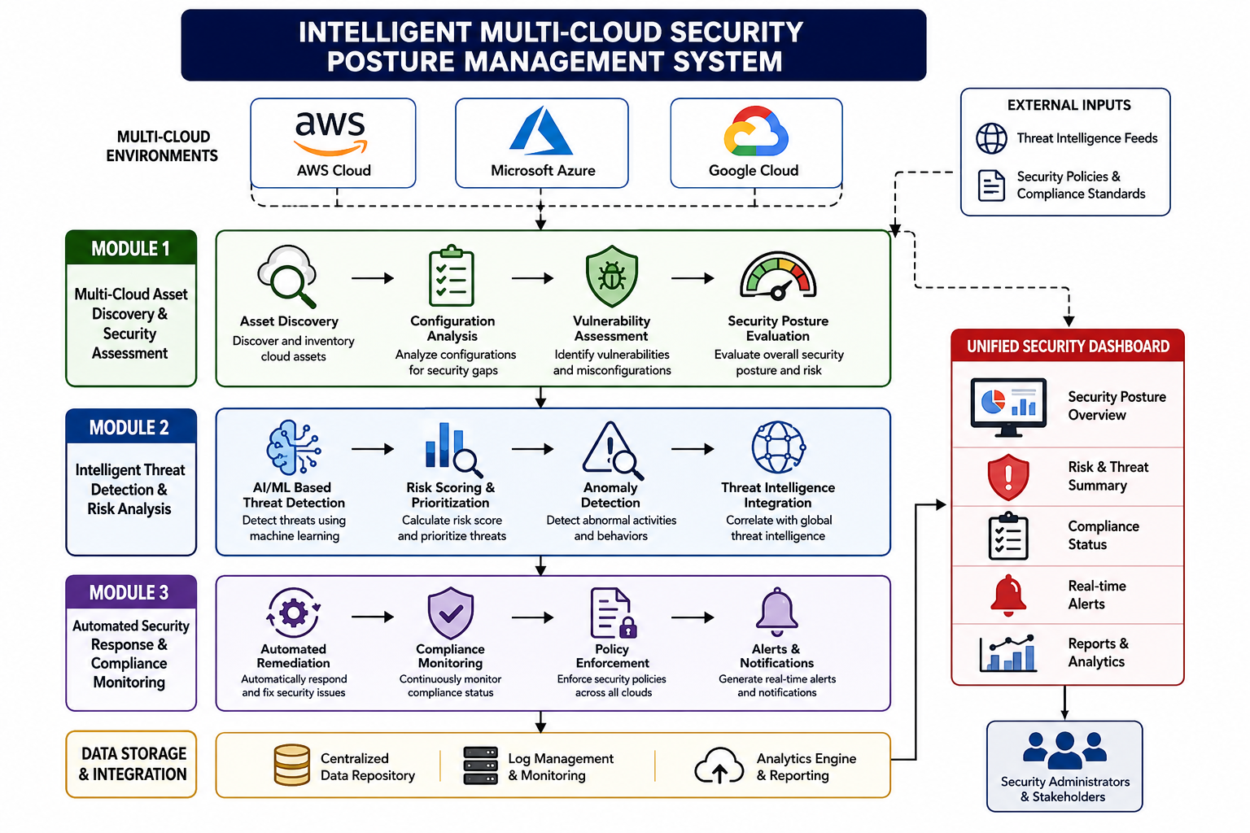
Figure 2. Overall MCSPM architecture.

3.2 Architecture Components
Layer | Main Function
Cloud provider layer | AWS, Azure and Google Cloud resources
Collection layer | Authorized cloud information retrieval
Asset layer | Inventory and resource classification
Assessment layer | Configuration and vulnerability analysis
Intelligence layer | Threat and anomaly detection
Risk layer | Severity, likelihood and impact analysis
Response layer | Security actions and remediation
Compliance layer | Policy checking and reporting
Presentation layer | Dashboard, alerts and reports

3.3 Architecture Principles
- Centralized visibility without eliminating provider-specific controls.
- Least-privilege access to cloud environments.
- Separation of detection and response decisions.
- Traceability through security and audit records.
- Controlled automation for high-impact actions.
- Scalability as asset and event volumes increase.

3.4 Module 1 Overview
The first module establishes visibility over cloud resources. The project presentation states that the module automatically discovers and inventories resources across AWS, Azure and Google Cloud. It also performs cloud configuration assessment, vulnerability identification, security posture evaluation and centralized asset visibility. fileciteturn2file0L87-L96

3.5 Asset Discovery Process
- Establish authorized connectivity to a supported cloud environment.
- Collect resource metadata through permitted interfaces.
- Normalize provider-specific information into a common inventory.
- Classify resources by type and security relevance.
- Record the last discovery time and current status.
- Expose inventory information through the central dashboard.

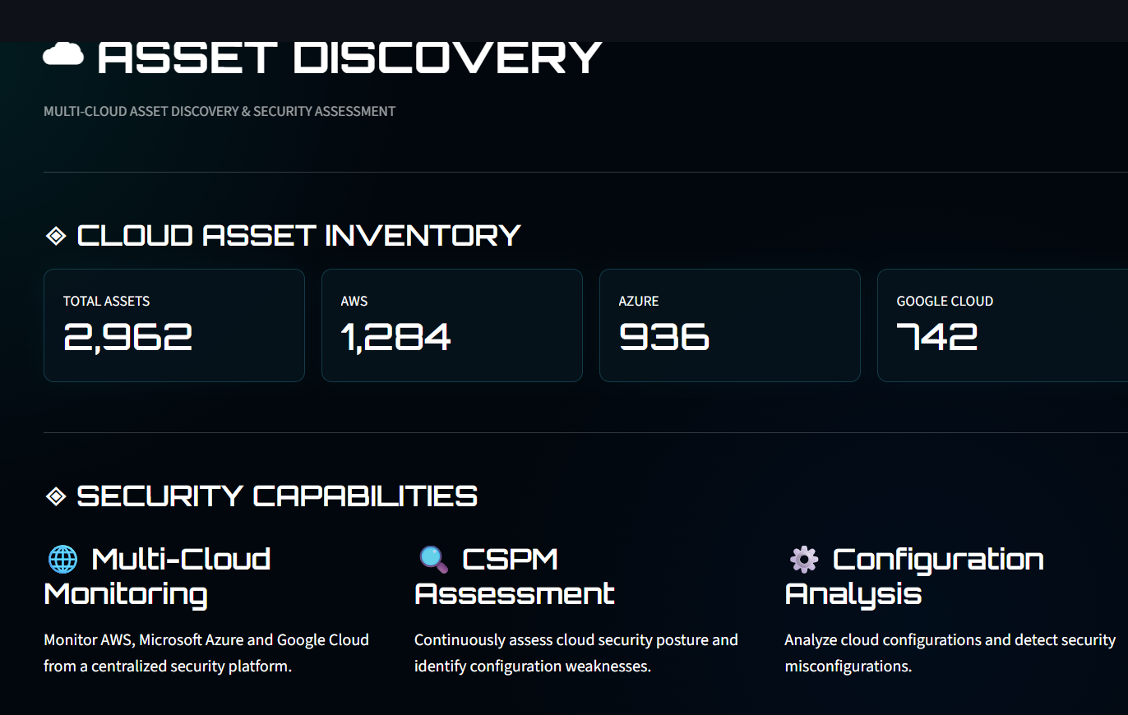

Figure 3. Multi-cloud asset discovery workflow.

3.6 Suggested Asset Record
Field | Purpose
Provider | Identifies the cloud platform
Resource ID | Unique resource reference
Resource type | Classifies the resource
Region/location | Provides deployment context
Owner/tag | Supports accountability
Configuration state | Security assessment status
Vulnerability state | Weakness status
Risk level | Priority information
Last checked | Freshness of information

3.7 Importance of Inventory
Security assessment is only as complete as the inventory on which it operates. An unmanaged resource can become a blind spot. Therefore, asset discovery is treated as the foundation of the proposed system.

3.8 Configuration Assessment
Configuration assessment checks security-relevant settings against defined organizational expectations. The project identifies misconfigurations and policy violations as explicit targets. Assessment results should include the affected resource, violated policy, severity and recommended action.

3.9 Vulnerability Identification
Vulnerability identification detects weaknesses that may expose cloud resources to cyber threats. The system should associate each vulnerability with its affected asset and risk context so that security teams can prioritize remediation.

3.10 Security Posture Evaluation
The presentation reports a 94.7% security posture score. A posture score is useful as a management indicator because it condenses many findings into a high-level view. However, the scoring formula is not specified in the supplied material, so the final report should not claim a particular weighting method.

3.11 Posture Score Interpretation
For a rigorous implementation, the posture score should be reproducible. The system should document which controls contribute to the score, how severity affects it and how remediation changes the result. Historical posture values would also allow trend analysis.

3.12 Centralized Visibility
A centralized dashboard can allow users to filter assets by provider, severity, resource type, compliance state and remediation status. This reduces the need to manually compare separate cloud environments.

3.13 Module 2 Overview
Module 2 provides the intelligent analysis layer. It includes AI-based threat detection, anomaly detection, risk assessment, threat-intelligence analysis and real-time security alerts. fileciteturn2file0L100-L109

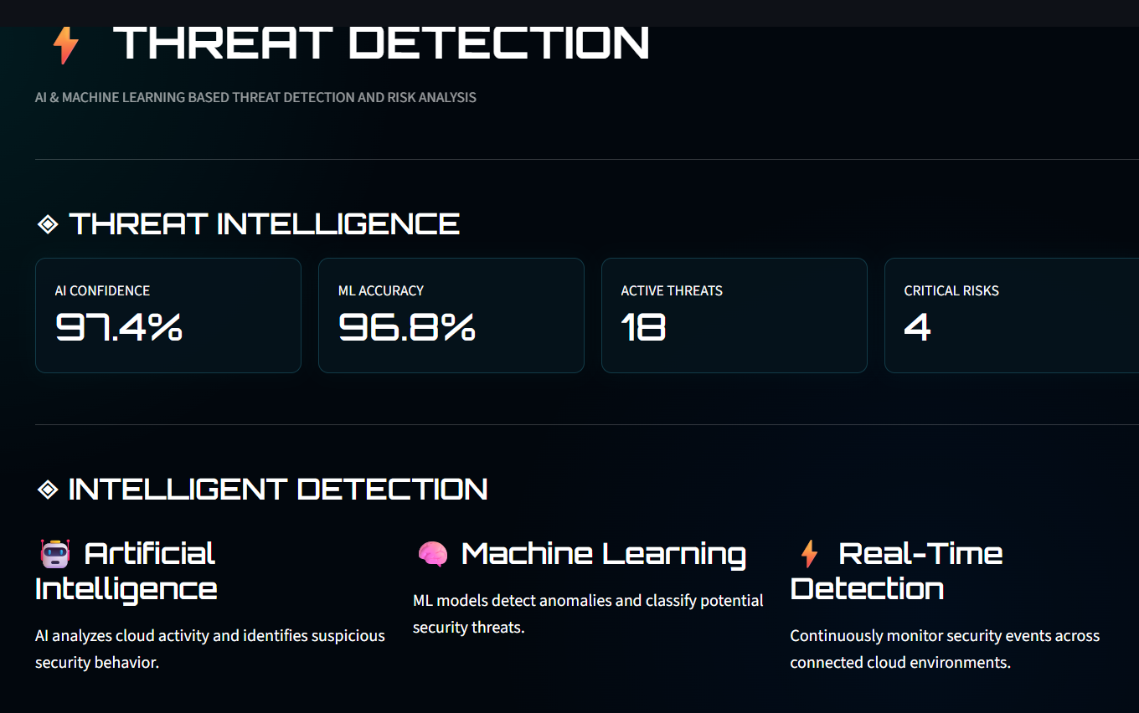
Figure 5. Intelligent threat detection workflow.

3.14 Activity Analysis
Cloud activity may contain information about users, network traffic and resource operations. The project identifies these three categories as sources of unusual behaviour. Activity analysis should preserve enough context to allow analysts to understand why an event was considered suspicious.

3.15 Anomaly Detection
Anomaly detection compares observed activity with an expected pattern. An effective detector should account for legitimate changes and planned administrative activities. Contextual information can reduce unnecessary alerts.

3.16 Threat Classification
Classification converts suspicious activity into a meaningful threat category or finding. This allows response policies to be associated with different types of incidents.

3.17 Real-Time Alerts
Real-time alerts provide immediate notification of important events. Alert records should include asset identity, event description, severity, time, risk level and recommended action.

CHAPTER 3 – RISK MODEL, THREAT INTELLIGENCE AND RESPONSE

3.18 Risk Model
A conceptual risk score can combine severity, likelihood and business impact. A simple normalized model may be expressed as:
Risk Priority ∝ Severity × Likelihood × Business Impact
The expression is a conceptual engineering model rather than a claim about the project's exact implemented formula. It illustrates why a technical finding should be evaluated in context.

3.19 Risk Prioritization
Severity | Likelihood | Impact | Priority Example
High | High | High | Critical
High | Medium | High | High
Medium | High | Medium | High
Medium | Medium | Medium | Medium
Low | Low | Low | Low

3.20 Threat Intelligence Correlation
Threat intelligence can provide context for suspicious activity by associating events with known attack patterns. Correlation can increase confidence in a finding and help analysts decide which events require immediate attention.

3.21 Risk-to-Response Mapping
Risk Level | Typical Response
Critical | Immediate alert and controlled high-priority response
High | Priority investigation and approved remediation
Medium | Scheduled corrective action
Low | Monitor and address during routine maintenance

3.22 Safe Automation Principle
Automation should not mean unrestricted execution. High-impact actions should be governed by authorization, policy thresholds, validation and audit logging. A hybrid model can automatically address low-risk conditions while requiring approval for actions that could affect availability.

3.23 Module 3 Overview
The third module connects security findings to action. The presentation identifies automated security response, compliance monitoring, security policy enforcement, automated remediation and real-time reporting and alerts. fileciteturn2file0L113-L122

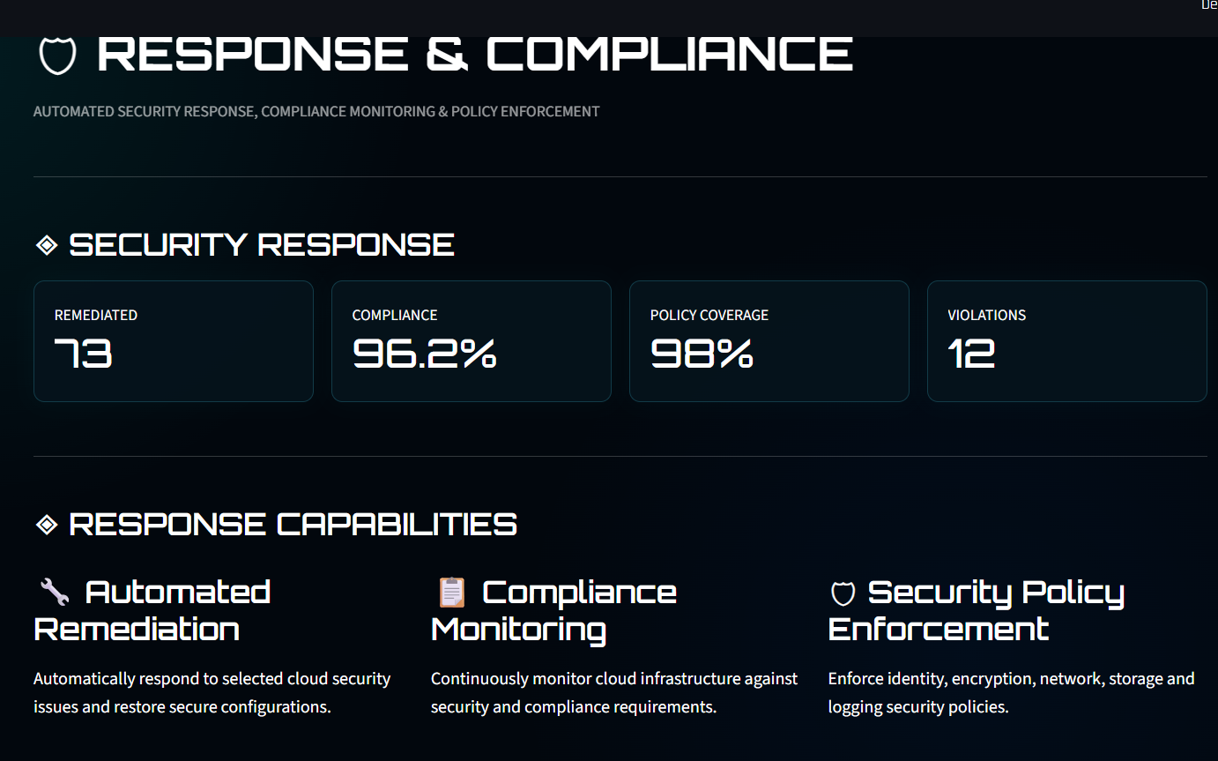

Figure 8. Automated security response and remediation workflow.

3.24 Automated Security Response
Automated response can initiate predefined security actions when a threat meets a defined policy condition. The response should be associated with an audit event so that administrators can understand what happened and why.

3.25 Security Policy Enforcement
Security policies provide a common set of expectations across cloud platforms. Because providers differ, the system should translate common organizational requirements into provider-specific checks.

3.26 Automated Remediation
Remediation corrects eligible security weaknesses. The safest design uses predefined actions, authorization checks, validation and post-remediation assessment.

3.27 Compliance Monitoring
Continuous compliance monitoring provides ongoing visibility into policy status. The project reports that continuous compliance monitoring is enabled together with real-time monitoring and automated reporting. fileciteturn2file0L132-L140

3.28 Reporting and Audit Logs
Reports provide management-level visibility while audit logs preserve operational traceability. Together they support accountability and help security teams demonstrate that corrective actions were performed.

3.29 Threat Model
Threat | Impact | Mitigation
Cloud misconfiguration | Exposure/unauthorized access | Continuous configuration assessment
Unauthorized access | Resource compromise | Access monitoring and policy enforcement
Credential compromise | Privilege misuse | Secure credential management
Suspicious behaviour | Potential intrusion | Anomaly detection
Malicious network activity | Service compromise | Network/activity analysis
Vulnerable resource | Exploitation | Vulnerability identification
Policy violation | Compliance failure | Continuous policy checks
Delayed response | Extended exposure | Real-time alerts/automation
False positive | Analyst overload | Correlation and tuning
Incorrect remediation | Service disruption | Controlled actions and validation

3.30 Risk Register
Risk | Likelihood | Impact | Mitigation
API/data collection failure | Medium | Medium | Retries, error handling and monitoring
False positive | Medium | Medium | Model validation and context
Missed threat | Medium | High | Multiple detection signals
Incorrect automated action | Low/Medium | High | Approval thresholds and rollback
Credential exposure | Low | High | Secure secret storage
Compliance mapping error | Medium | High | Policy review
Inventory mismatch | Medium | Medium | Periodic discovery

3.31 Ethical Hacking Considerations
All assessment and testing activities must be performed on authorized systems. The project should avoid collecting unnecessary sensitive information and should protect cloud credentials. Vulnerability findings should be handled responsibly and disclosed to the appropriate authorized stakeholder.

3.32 Sustainability
Centralized monitoring reduces duplicated manual effort. Automation can reduce repetitive operational tasks and allow security personnel to focus on higher-priority incidents. A scalable platform can also reduce the need for multiple disconnected monitoring workflows.

3.33 Standards and Framework Alignment
Reference | Project Relevance
NIST SP 800-53 Rev. 5 | Security and privacy control reference
NIST CSF 2.0 | Cybersecurity risk-management structure
ISO/IEC 27001:2022 | Information-security management reference
CSA Security Guidance v5.0 | Cloud-security guidance
AWS Well-Architected Security Pillar | AWS security design guidance
Microsoft Azure Security Documentation | Azure security controls
Google Cloud Security Best Practices | Google Cloud security practices

These references are included in the project presentation's reference list. fileciteturn2file0L168-L178

3.34 Design Trade-Offs
Decision | Alternative | Trade-Off | Selected
Central dashboard | Separate dashboards | Integration complexity vs visibility | Central
AI detection | Rules only | Higher analytics capability vs tuning needs | AI + analytics
Automation | Manual response | Speed vs operational risk | Controlled automation
Continuous monitoring | Periodic checks | Freshness vs resource use | Continuous
Multi-cloud | Single cloud | Coverage vs integration complexity | Multi-cloud

3.35 Privacy and Data Minimization
Security monitoring should collect only the information needed for assessment and detection. Sensitive data should be protected during collection, processing and storage. Access should be restricted according to role and operational necessity.

3.36 Role-Based Access
A future enterprise implementation should distinguish administrators, security analysts, auditors and management users. Role-based access reduces accidental changes and supports separation of duties.

CHAPTER 4 – IMPLEMENTATION AND USER INTERFACE

4.1 Development Methodology
- Problem identification
- Requirements analysis
- Architecture design
- Asset discovery implementation
- Security assessment implementation
- Threat detection and risk analysis
- Response and compliance implementation
- Dashboard integration
- Testing
- Results analysis
- Documentation

4.2 Implementation Workflow
The overall implementation follows the sequence Discover → Assess → Detect → Analyse → Prioritize → Respond → Remediate → Verify → Report. This sequence ensures that security management is treated as a continuous process rather than as isolated activities.

4.3 User Interface
The project presentation contains a User Interface Design section. The final report should include the actual project screenshot rather than an unrelated dashboard. The interface should present posture, assets, threats, critical risks, AI confidence, compliance state, alerts and reports.
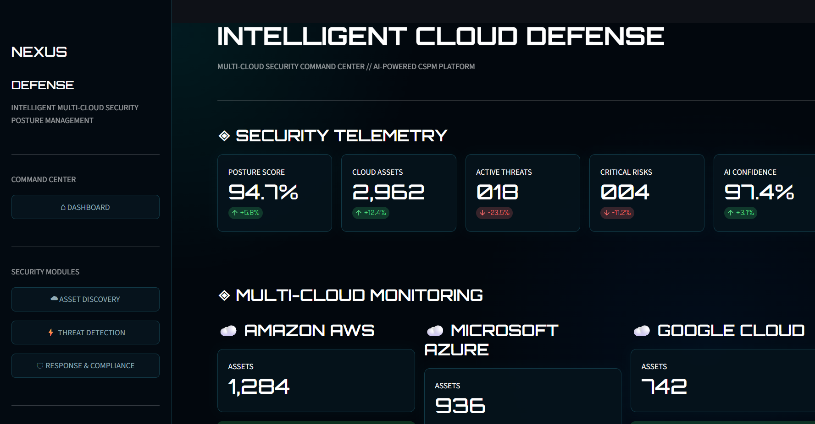

Figure 10. MCSPM user interface.

4.4 Dashboard Information Architecture
Dashboard Area | Information
Posture | Overall security posture
Assets | Total and provider-wise inventory
Threats | Active threats and categories
Critical risks | Highest-priority findings
AI indicator | Reported confidence
Compliance | Policy/standard status
Alerts | Recent security events
Remediation | Open and completed actions
Reports | Security and compliance evidence

4.5 Functional Test Plan
ID | Test | Expected Result
TC01 | AWS discovery | AWS resources appear in inventory
TC02 | Azure discovery | Azure resources appear in inventory
TC03 | Google Cloud discovery | Google Cloud resources appear in inventory
TC04 | Configuration assessment | Misconfigurations identified
TC05 | Vulnerability identification | Weaknesses identified
TC06 | Posture calculation | Security posture displayed
TC07 | Anomaly detection | Suspicious behaviour identified
TC08 | Threat classification | Threat category assigned
TC09 | Risk scoring | Risk priority generated
TC10 | Alert generation | Security alert generated
TC11 | Automated response | Approved action initiated
TC12 | Remediation | Eligible issue corrected
TC13 | Compliance monitoring | Compliance status updated
TC14 | Audit logging | Action recorded
TC15 | Dashboard | Information displayed centrally

4.6 Reported Results
Metric | Reported Result
Security posture score | 94.7%
Cloud assets discovered/monitored | 2,962
Active threats | 18
Critical risks | 4
AI confidence in threat detection | 97.4%
Continuous compliance monitoring | Enabled
Automated reporting | Enabled

The above values are taken from the project presentation's Results section. fileciteturn2file0L130-L140

4.7 Results Interpretation
The 94.7% posture score indicates the project's reported high-level security posture. The 2,962 asset count demonstrates the scale of the centralized inventory. The 18 active threats and four critical risks provide a prioritized view of security issues. The 97.4% AI confidence indicates the reported confidence level, but additional statistical metrics are required to establish model accuracy.

4.8 Objective Achievement
Objective | Evidence | Status
Asset inventory | 2,962 assets reported | Achieved
Security assessment | Module 1 | Achieved
AI threat detection | 97.4% reported confidence | Achieved
Risk prioritization | 18 threats and 4 critical risks | Achieved
Automated response | Module 3 | Achieved
Compliance monitoring | Continuous monitoring enabled | Achieved

4.9 Strengths
- Unified multi-cloud visibility
- Integration of security posture and threat analysis
- AI-assisted detection
- Risk prioritization
- Automated response and remediation
- Continuous compliance monitoring
- Real-time reporting

4.10 Limitations
- The exact AI algorithm and training dataset are not specified in the supplied presentation.
- The posture-score formula is not specified.
- The reported AI confidence is not equivalent to a complete accuracy evaluation.
- Detailed performance benchmarks are not provided.
- Provider-specific implementation details are not fully documented in the presentation.
- Automated remediation requires careful operational controls.
- Detailed control-to-standard compliance mapping should be added for stronger evidence.

4.11 Project Management
Phase | Deliverable
Problem definition | Problem statement and scope
Literature review | Technical background
Requirements | Functional/non-functional requirements
Architecture | Block diagram
Module 1 | Asset discovery and assessment
Module 2 | Threat detection and risk
Module 3 | Response and compliance
Integration | Dashboard
Testing | Test evidence
Results | Metrics and analysis
Documentation | Final report

.

CHAPTER 5 – CONCLUSION, FUTURE SCOPE AND REFLECTION

5.1 Conclusion
The Intelligent Multi-Cloud Security Posture Management System provides a centralized approach to securing multiple cloud environments. It addresses the fragmented visibility, configuration, compliance, detection and manual-management problems identified in the project.
The three-module structure provides a logical security lifecycle. Module 1 establishes visibility and posture assessment. Module 2 detects suspicious activity and prioritizes risks. Module 3 connects security findings to automated response, remediation and compliance monitoring.
The reported project outcomes include a 94.7% security posture score, 2,962 monitored cloud assets, 18 active threats, four critical risks and 97.4% AI confidence. The presentation also reports continuous compliance monitoring and automated reporting. fileciteturn2file0L130-L140

5.2 Future Scope
- Extend support to additional public, private and hybrid cloud platforms.
- Introduce predictive AI for earlier threat identification.
- Integrate Zero Trust security architecture.
- Expand automated compliance auditing.
- Develop self-healing cloud security with controlled automation.
- Integrate SIEM/SOC platforms.
- Add attack-path and security-graph analysis.
- Improve explainability of AI decisions.
- Add historical posture trends and remediation-time analytics.
- Perform large-scale accuracy, performance and scalability benchmarking.
The project presentation itself identifies additional cloud integration, advanced AI threat prediction, Zero Trust, enhanced compliance automation and self-healing cloud security as future directions. fileciteturn2file0L156-L165

5.3 Final Reflection
The project demonstrates how ethical-hacking concepts can be integrated with cloud-security engineering. The key learning outcome is that security management requires a continuous cycle of discovery, assessment, detection, prioritization, response and verification. Future development should focus on reproducible testing, transparent scoring, quantitative AI evaluation and safe automation.

REFERENCES
[1] NIST, Security and Privacy Controls for Information Systems and Organizations, SP 800-53 Rev. 5, 2020.
[2] Cloud Security Alliance, Security Guidance for Critical Areas of Focus in Cloud Computing v5.0, 2024.
[3] ISO/IEC 27001:2022 – Information Security, Cybersecurity and Privacy Protection.
[4] AWS Well-Architected Framework – Security Pillar.
[5] Microsoft Azure Security Documentation.
[6] Google Cloud Security Best Practices.
[7] NIST Cybersecurity Framework (CSF) 2.0, 2024.
[8] IEEE Xplore research on multi-cloud security, CSPM and AI-based threat detection.
[9] Microsoft Defender for Cloud documentation.
[10] Palo Alto Networks Prisma Cloud CSPM documentation.

APPENDIX – EVIDENCE CHECKLIST
- Original block diagram
- Actual user-interface screenshot
- Asset discovery evidence
- Configuration assessment evidence
- Threat detection evidence
- Risk analysis evidence
- Automated response/remediation evidence
- Compliance report
- Audit logs
- Team contribution evidence

